|  |  |
| --- | --- |
| Offeror Qualifications & Information Req. | Section |
| 4 |

**4.1.1 References**

FileONE has the industry’s leading direct subject matter expertise. With each implementation, FileONE has met the unique challenges and objectives of enterprise-wide Secretary of State implementations. Our extensive library of domain expertise is unmatched and critical to the success of this project. FileONE can match our commitment to meet the needs of this RFP with the knowledge base we have developed through each Business Services implementation. FileONE offers the following project references:

**New Hampshire Secretary of State**

Contact Information: Laurie Harrigan; (603) 271-0716; laurie.harrigan@sos.nh.gov

Project Overview:

In mid- 2008, FileONE contracted with the NH SOS as an early adopter for SystemWORKS. As an Early Adopter, the NH SOS partnered and continues to partner with FileONE on the design and functionality of SystemWORKS. The NH SOS originally contracted with FileONE in 2003 to implement the SOSKB Business Entity, UCC, Trademark and Vital Records system. Similar in nature to Montana’s goals, these collective modules replaced the State’s fragmented legacy applications that previously prohibited comprehensive online filing and research. The project was a tremendous success. It quickly improved efficiencies, raised NH SOS staff satisfaction, and most importantly, improved services for non-governmental stakeholders. With the assistance of the FileONE Business Process Team, the NH SOS’s online filing of annual reports is over eighty (80) percent.

**Pennsylvania Department of State**

Contact Information: Richard House; (717) 783-9210; rihouse@state.pa.us

Project Overview:

FileONE partnered with the PA DOS in 2004 to implement a UCC and Business Entity system. The PA DOS had selected a vendor that was ultimately unable to deliver an adequate system for the DOS. In fact, the DOS in Harrisburg’s processing backlog had extended beyond two months. FileONE implemented the UCC system in just over 60 days. Shortly thereafter, the DOS’s entire backlog was eliminated. Moreover, the DOS is currently processing documents within one business day. Following the UCC implementation, FileONE deployed the Business Entity system which in turn mirrored the success of the UCC implementation. FileONE continues to support the PA DOS, with the system supporting one of the most comprehensive, rapid, and efficient Business Services Management offices in the country.

**Georgia Secretary of State**

Contact Information: Chauncey Newsome; (404) 657-4988; cnewsome@sos.state.ga.us

Project Overview:

FileONE partnered with the GA SOS in 2004 to implement a new Business Entity system. Previously, GA’s collection of legacy applications offered limited online services for its customers. In 2004, the GA SOS selected FileONE to incorporate our functional and business process best practices to deliver a complete desktop and online filing solution. As one of the largest filing offices in the country, FileONE has continuously met the stringent technical and client services demands of the GA SOS and its customers. FileONE continues to support and enhance the services provided by the GA SOS.

**4.1.2 Company Profile and Experience**

Founded in 1998, FileONE has established itself as the Business Services Management Systems market leader. To date, FileONE has partnered with eleven Secretaries of State to implement and support various mission-critical business services management solutions. The timeline below highlights FileONE’s implementation by module and date.

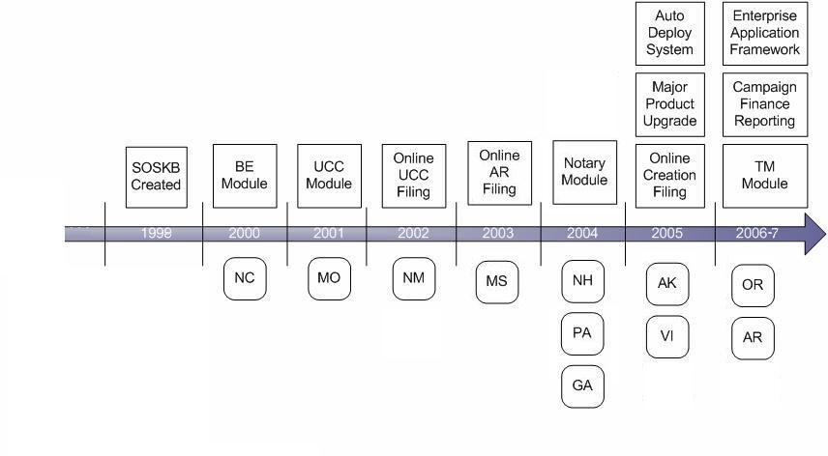

With each successful implementation, FileONE has created an unmatched library of best practices and specific subject matter expertise that is critical to the success of the MT SIMS project. Moreover, as an active and leading sponsor in the International Association of Commercial Administrators (IACA), FileONE is dedicated to ensuring that the industry’s latest requirements and trends are incorporated into our solutions. With over 50 employees dedicated to SOS Business Services, no other competing offeror can match our expertise at the macro or micro level. Our collective level of knowledge and experience helps to both minimize the risk while maximizing the success potential of every project we undertake.

The table below highlights FileONE’s extensive experience supporting key Business Processing jurisdictions. Our support expertise and the library of best practices FileONE has developed limits both the short and long term risk associated with lost domain knowledge through attrition or costly errors due to general inexperience.

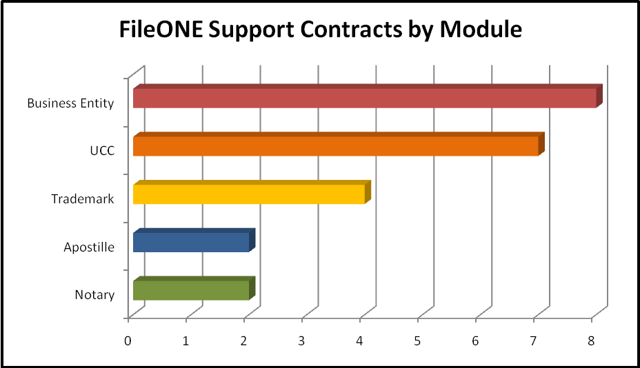

FileONE is a wholly owned subsidiary of Elections Systems and Software (ES&S). Over its 39-year history, ES&S has grown into the world’s largest election technology and management services company by providing high quality products and services. ES&S is proud of its successful election record, and shares FileONE’s commitment to providing excellent service to US Secretaries of State and similar entities throughout North America and abroad.

**4.1.3 Method of Providing Services**

FileONE has supplied a Work Breakdown Summary in section 3.1.12. As part of final contracting on the initial project phase, FileONE and the MT SOS will mutually agree upon a work plan outlining key milestone delivery dates. This schedule will take into account the blackout dates included in RFP section 3.1.12 “Development Phases” to ensure that SystemWORKS module go-lives do not occur during the periods defined. Additional details regarding FileONE’s project methodology can be found throughout our proposal response section 3 above.

**4.1.4 Offeror Financial Stability**

FileONE is backed not only by ES&S’s strong financials, but a shared dedication to supporting Secretaries of State through large-scale, enterprise-wide solutions. By merging our specific Secretary of State domain knowledge with ES&S’s financial strength we bring a strong experienced team and solid financial backing to this project. **With our strong financial position, we are well positioned to offer the required resource and financial investments in this project now, and more importantly, in the future.**

ES&S and FileONE are C-corporations. The dates of incorporation for ES&S and FileONE are 12/20/1990 and 2/25/1999, respectively. One hundred percent (100%) of the outstanding stock in FileONE is owned by ES&S. ES&S is owned by Government Systems, Software & Services, Inc. ("GS3") a holding company with an  ownership breakdown as follows: 85% of outstanding stock is held by three major investors: The McCarthy Group, an Omaha-based Investment Banking Concern, World Investments, a wholly owned subsidiary of the Omaha World Herald, and Normal Investments, an entity owned by Norm Waitte, a co-founder of Gateway Computer. The remaining 15% is held by employees.

The total number of FileONE and ES&S employees is 376. The total number of FileONE staff currently numbers 55. ES&S and FileONE are projected to reach $125 million in revenues for fiscal year 2008.

ES&S and FileONE hereby certify that there are no judgments, pending or expected litigation, or other real potential financial reversals which might materially affect the viability or stability of the respective organizations.

Please note, we changed our name from Office Automation Solutions, Inc. to FileONE, Inc. in September, 2007 to more accurately reflect our focus on Secretary of State Business filing solutions. FileONE and ES&S financials were combined when FileONE was acquired by ES&S in March, 2007.

Please find the attached confidential Financial Statements in a separate sealed envelope.

**4.1.5 Local Presence**

FileONE is providing a significant local presence through Helena-based FrontDesk Software for the duration of the SIMS deployment and RFP-stated warranty period. FileONE and FrontDesk Software will provide the MT SOS with persistent hands-on project oversight, as well as continuous software improvements and responsive system maintenance in the near and long term future.

Our partnership will feature a balance of onsite (Helena) resources to effectively manage MT SOS project expectations and offsite resources to leverage FileONE’s entire SystemWORKS product team. A list of key resources, including full-time and part-time onsite resources is included in the table in response section 4.1.6 below.

**4.1.6 Key Personnel**

FileONE has identified the following key resources and milestone leads who will be onsite either full-time or during the various SIMS implementation and warranty phases of the project. Resumes for the key personnel below are included in Appendix D, “Key Personnel Resumes.”

|  |  |  |  |
| --- | --- | --- | --- |
| **Resource** | **Role** | **Effort** | **Helena Based**  **(full time)** |
| Robbie Robinson | Project Manager | 5200 | ✓ |
| Glen Gormley | Software Engineer | 3780 | ✓ |
| Dave Sedlock | Data Conversion Specialist | 4340 | ✓ |
| Jacqui Safis | Business Analyst | 4620 | ✓ |
| Pat Foley | Quality Assurance Specialist | 3590 | ✓ |
| Sebastian Dorin | Software Trainer | 620 |  |
| Jody Fulghum | System Engineer | 600 |  |
| Daljit Singh | Database Administrator | 700 |  |
| Steven Lynch | Application Development Lead | 800 |  |

* Note: Effort in hours for the Key Milestone leads and the Training Lead is for the total project effort and is not broken down by number of hours onsite and offsite.

In the unlikely event that a key staff member must be replaced, FileONE will request written approval of the MT SOS and provide a suitable replacement.

**FileONE Resource Pool and Experience**

To demonstrate our extensive experience and resource pool of dedicated project resources, FileONE has included a list of the entire SystemWORKS™ project team including individual roles as well as total years of relevant domain experience. This table highlights our capability to deliver a comprehensive solution the meets the unique needs of Secretaries of State.

* Accounting (noted as “AC”)
* Workflow (noted as “WF”)
* Correspondence (noted as “CO”)
* Imaging (noted as “IM”)
* Record Retention (noted as “RR”)
* Retrieval (noted as “RV”)
* Record Purging (noted as “RP”)
* Data Conversion (noted as “DC”)
* Business Process Reengineering (noted as “BPR”)

| Resource* | Role | AC1 | WF2 | CO3 | IM4 | RR5 | RV6 | RP7 | DC8 | BPR9 |
| --- | --- | --- | --- | --- | --- | --- | --- | --- | --- | --- |
| Bali, Hermeet | Quality Engineer | 5 | 4 | 12 | 4 | 8 | 8 | 8 | 1 | 8 |
| Barnard, Elton | Software Engineer | 1 | 13 | 3 | 3 | 25 | 25 | 25 | 15 | 15 |
| Cao, Yong | Software Engineer | 8 | 1 | 3 | 8 | 8 | 8 | 8 | 8 | 8 |
| Charlier, Claudia | Business Analyst | 3 | 11 | 5 | 11 | 11 | 11 | 8 | 1 | 11 |
| Cook, Wade | Software Engineer | 5 | 5 | 10 | 0 | 5 | 20 | 10 | 20 | 20 |
| Diacont, Doug | Software Engineer | 2 | 3 | 0 | 0 | 12 | 12 | 12 | 12 | 12 |
| Dice, Nancy | Quality Engineer | 6 | 3 | 10 | 3 | 10 | 10 | 10 | 10 | 8 |
| Dorin, Sebastian | Assoc. Product Mgr | 8 | 8 | 5 | 8 | 6 | 6 | 6 | 8 | 15 |
| Dyer, Jeff | Software Engineer | 2 | 2 | 5 | 7 | 5 | 4 | 5 | 4 | 4 |
| Foley, Pat | Quality Engineer | 3 | 15 | 3 | 3 | 3 | 3 | 3 | 20 | 12 |
| Fulghum, Jody | System Administrator | 1 | 4 | 4 | 4 | 4 | 4 | 4 | 4 | 1 |
| Fullbright, Marcy | Software Engineer | 2 | 2 | 5 | 2 | 2 | 2 | 2 | 5 | 2 |
| Gabor, William | Technical Writer | 6 | 8 | 8 | 8 | 5 | 5 | 7 | 7 | 7 |
| Gormely, Glen | Software Engineer | 3 | 7 | 10 | 5 | 5 | 5 | 2 | 10 | 10 |
| Hetland, Brent | Software Engineer | 4 | 8 | 10 | 10 | 7 | 7 | 6 | 6 | 8 |
| Homsher, Michael | Dir of Product Dev. | 10 | 14 | 9 | 1 | 12 | 15 | 5 | 20 | 15 |
| Jones, Janet | Quality Engineer | 2 | 3 | 3 | 1 | 2 | 2 | 2 | 4 | 4 |
| Karnatz, Tom | Software Engineer | 14 | 3 | 6 | 3 | 14 | 14 | 2 | 11 | 11 |
| Kennedy, Viki | Impl. Team Lead | 10 | 10 | 10 | 8 | 10 | 10 | 8 | 10 | 10 |
| Leeds, Ray | Software Architect | 20 | 15 | 15 | 6 | 4 | 4 | 4 | 24 | 15 |
| Lynch, Steven | Application Architect | 17 | 10 | 5 | 5 | 20 | 20 | 20 | 20 | 10 |
| MacDougall, Dan | Business Analyst | 12 | 12 | 12 | 3 | 12 | 12 | 6 | 4 | 12 |
| Mannato, Lyn | Software Engineer | 5 | 4 | 3 | 3 | 3 | 3 | 4 | 5 | 5 |
| Milora, Robyn | Technical Writer | 3 | 3 | 4 | 5 | 5 | 7 | 3 | 3 | 8 |
| Morgan, Bryan | Software Engineer | 15 | 15 | 15 | 15 | 15 | 15 | 15 | 15 | 10 |
| Naik, Murali | Software Engineer | 2 | 2 | 2 | 1 | 5 | 3 | 3 | 2 | 2 |
| Neuenschwander, Mark | Database Admin | 5 | 2 | 2 | 1 | 10 | 10 | 7 | 12 | 5 |
| Owens, Regina | Business Analyst | 12 | 12 | 19 | 7 | 19 | 7 | 10 | 12 | 12 |
| Safis, Jacqui | Business Analyst | 8 | 6 | 3 | 4 | 4 | 2 | 4 | 1 | 8 |
| Sedlock, Dave | Database Developer | 2 | 4 | 5 | 0 | 5 | 5 | 5 | 4 | 4 |
| Singh, Ajai | Software Engineer | 5 | 1 | 3 | 1 | 3 | 8 | 6 | 1 | 9 |
| Singh, Daljit | Database Admin | 3 | 3 | 6 | 3 | 8 | 12 | 8 | 15 | 7 |
| Sitser, Shannon | Software Engineer | 3 | 8 | 3 | 2 | 6 | 6 | 6 | 6 | 6 |
| Sridhar, Mona | Software Engineer | 4 | 5 | 5 | 5 | 5 | 4 | 4 | 4 | 5 |
| Small, David | Software Engineer | 6 | 5 | 2 | 2 | 4 | 4 | 2 | 5 | 7 |
| Van Roy, Craig | Product Manager | 10 | 12 | 10 | 10 | 12 | 10 | 10 | 10 | 12 |

***LEGEND:***  **AC1**: accounting; **WF2**: workflow **CO3**: correspondence; **IM4**: imaging; **RR5**: record retention; **RV6**: retrieval; **RP7**: record purging;

**DC8**: data conversion; **BPR9**: business process reengineering

* The resources listed, unless also noted in the key personnel table in section 4.1.6, are not to be consider Key Personnel

**4.1.7 Oral Presentation/Product Demonstration**

FileONE welcomes the opportunity to demonstrate SystemWORKS and to provide section-by-section clarification of our SIMS proposal. Prior to the demonstration, FileONE will provide a list of attendees, including title, tenure and their relationship to this project.